AI-POWERED CONTENT CREATION CONCEPT
Tasks
1.Use ChatGPT or Gemini to generate 5 catchy Instagram post captions for a new Zomato restaurant launch event.
=> Answer :
1. A new food destination is coming.
2. Get ready for delicious moments.
3. Your next favourite restaurant has arrived.
4. Good food, great vibes, unforgettable moments.
5. Taste something new with us.

2.Write a product description for a trending sneaker on Myntra using your own words, then use any free AI content tool (like Copy.ai or Writesonic) to rewrite it to sound more engaging and compare the two versions.<br><br><em><strong>Hint:</strong> Focus on making the AI version more appealing for Gen Z shoppers.</em>
=> Answer :
Step up your sneaker game with these stylish, lightweight kicks made for Gen Z! Designed for everyday comfort and a trendy streetwear look, they are perfect for college days, hangouts, travel, and casual outings. Pair them with jeans, joggers, or your favourite outfit and make every step stand out.

3.Pick a favorite artist or playlist from Spotify and use an AI content generator to create a short blog post (100-150 words) recommending it to your friends.
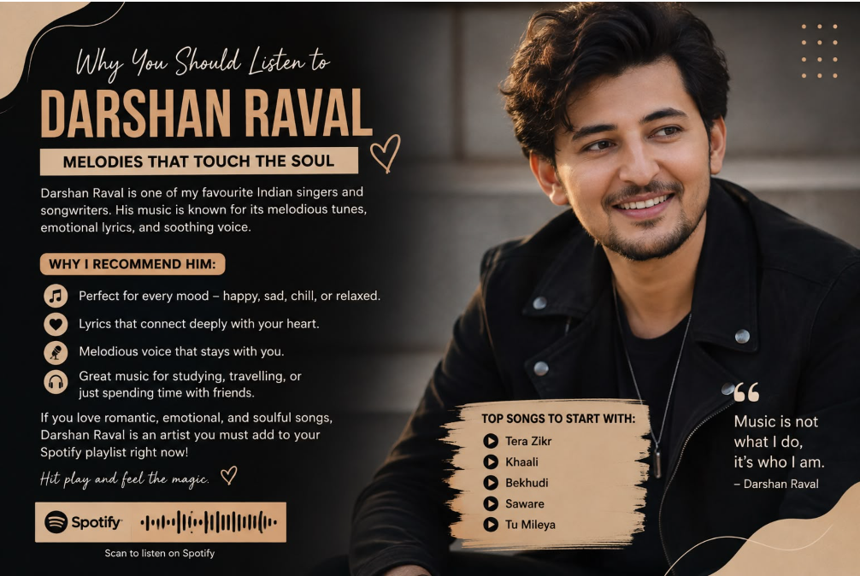

4.Use an AI image generation tool (like Canva AI or Bing Image Creator) to create a promotional banner for a Flipkart Big Billion Days sale, then save and submit the image file.<br><br><em><strong>Constraint:</strong> The banner must include a catchy headline and at least one product image.</em>
